Introduction to URDF: MANIPULATOR DESIGN AND CONTROL

http://wiki.ros.org/urdf/Tutorials/Adding%20Physical%20and%20Collision%20Properties%20to%20a%20URDF%20Model

Execute in Terminal #1
sudo apt-get install ros-foxy-teleop-twist-keyboard
sudo apt-get install ros-foxy-joint-state-publisher*
sudo apt-get install ros-foxy-joint-trajectory-controller
sudo apt-get install ros-foxy-controller-manager

cd ros2_ws/src/urdf_tutorial/urdf
touch manipulator.urdf

<?xml version="1.0"?>
<robot name="arm">

<link name="world"/>
<link name="base_link">
<visual>
<geometry>
<cylinder length="0.05" radius="0.2"/>
</geometry>
<material name="Black">
<color rgba="0 0 0 1"/>
</material>
<origin rpy="0 0 0" xyz="0 0 0.025"/>
</visual>

<collision>
<geometry>
<cylinder length="0.05" radius="0.2"/>
</geometry>
<origin rpy="0 0 0" xyz="0 0 0.025"/>
</collision>

<inertial>
<origin rpy="0 0 0" xyz="0 0 0.025"/>
<mass value="5.0"/>
<inertia ixx="0.0135" ixy="0.0" ixz="0.0" iyy="0.0135" iyz="0.0" izz="0.05"/>
</inertial>
</link>

<joint name="fixed" type="fixed">
<parent link="world"/>
<child link="base_link"/>
<dynamics damping="10" friction="1.0"/>
</joint>

<link name="link_1">
<visual>
<geometry>
<cylinder length="0.5" radius="0.08"/>
</geometry>
<material name="blue">
<color rgba="0 0 0.8 1"/>
</material>
<origin rpy="0 0 0" xyz="0 0 0.25"/>
</visual>

<collision>
<geometry>
<cylinder length="0.5" radius="0.08"/>
</geometry>
<origin rpy="0 0 0" xyz="0 0 0.25"/>
</collision>

<inertial>
<origin rpy="0 0 0" xyz="0 0 0.25"/>
<mass value="5.0"/>
<inertia ixx="0.107" ixy="0.0" ixz="0.0" iyy="0.107" iyz="0.0" izz="0.0125"/>
</inertial>

</link>

<joint name="joint_1" type="continuous">
<axis xyz="0 0 1"/>
<parent link="base_link"/>
<child link="link_1"/>
<origin rpy="0 0 0" xyz="0.0 0.0 0.05"/>
<dynamics damping="10" friction="1.0"/>
</joint>

<link name="link_2">
<inertial>
<origin rpy="0 0 0" xyz="0 0 0.2"/>
<mass value="2.0"/>
<inertia ixx="0.027" ixy="0.0" ixz="0.0" iyy="0.027" iyz="0.0" izz="0.0025"/>
</inertial>

<visual>
<geometry>
<cylinder length="0.1" radius="0.08"/>
</geometry>
<material name="Red">
<color rgba="1 0 0 1"/>
</material>
</visual>

<collision>
<geometry>
<cylinder length="0.1" radius="0.08"/>
</geometry>
</collision>
</link>

<joint name="joint_2" type="continuous">
<axis xyz="0 0 1"/>
<parent link="link_1"/>
<child link="link_2"/>
<origin rpy="0 1.5708 0" xyz="0.0 -0.005 0.58"/>
<limit lower="-0.25" upper="3.34" effort="10" velocity="0.5"/>
<dynamics damping="10" friction="1.0"/>
</joint>

<link name="link_3">
<inertial>
<origin rpy="0 0 0" xyz="0 0 0.2"/>
<mass value="0.01"/>
<inertia ixx="0.027" ixy="0.0" ixz="0.0" iyy="0.027" iyz="0.0" izz="0.0025"/>
</inertial>

<visual>
<geometry>
<cylinder length="0.4" radius="0.05"/>
</geometry>
<material name="blue">
<color rgba="0.5 0.5 0.5 1"/>
</material>
</visual>

<collision>
<geometry>
<cylinder length="0.4" radius="0.05"/>
</geometry>
</collision>
</link>

<joint name="joint_3" type="fixed">
<parent link="link_2"/>
<child link="link_3"/>
<origin rpy="1.57 0 0" xyz="0.0 0.2 0 "/>
<dynamics damping="10" friction="1.0"/>
</joint>

<link name="link_4">
<inertial>
<origin rpy="0 0 0" xyz="0 0 0.2"/>
<mass value="0.01"/>
<inertia ixx="0.027" ixy="0.0" ixz="0.0" iyy="0.027" iyz="0.0" izz="0.0025"/>
</inertial>

<visual>
<geometry>
<cylinder length="0.1" radius="0.06"/>
</geometry>
<material name="Red">
<color rgba="1 0 0 1"/>
</material>
</visual>

<collision>
<geometry>
<cylinder length="0.1" radius="0.06"/>
</geometry>
</collision>

</link>

<joint name="joint_4" type="continuous">
<parent link="link_3"/>
<child link="link_4"/>
<origin rpy="1.57 0 0" xyz=" 0 0 -0.25"/>
<axis xyz=" 0 0 1"/>
<limit lower="-1.92" upper="1.92" effort="10" velocity="0.5"/>
<dynamics damping="10" friction="1.0"/>
</joint>

<link name="link_5">
<inertial>
<origin rpy="0 0 0" xyz="0 0 0.2"/>
<mass value="0.01"/>
<inertia ixx="0.027" ixy="0.0" ixz="0.0" iyy="0.027" iyz="0.0" izz="0.0025"/>
</inertial>

<visual>
<geometry>
<cylinder length="0.3" radius="0.03"/>
</geometry>
<material name="yello">
<color rgba="0 1 0.5 1"/>
</material>
</visual>

<collision>
<geometry>
<cylinder length="0.3" radius="0.03"/>
</geometry>
<dynamics damping="0.0" friction="0.0"/>

</collision>
</link>

<joint name="joint_5" type="fixed">
<parent link="link_4"/>
<child link="link_5"/>
<origin rpy="1.57 0 0" xyz="0.0 -0.2 0 "/>
<dynamics damping="10" friction="1.0"/>
</joint>

<gazebo reference="base_link">
<material>Gazebo/Black</material>
</gazebo>

<gazebo reference="link_1">
<material>Gazebo/White</material>
</gazebo>

<gazebo reference="link_3">
<material>Gazebo/White</material>
</gazebo>

<gazebo reference="link_2">
<material>Gazebo/Blue</material>
</gazebo>

<gazebo reference="link_4">
<material>Gazebo/Blue</material>
</gazebo>

<gazebo reference="link_5">
<material>Gazebo/White</material>
</gazebo>

<gazebo>
<plugin filename="libgazebo_ros2_control.so" name="gazebo_ros2_control">
<robot_sim_type>gazebo_ros2_control/GazeboSystem</robot_sim_type>
<parameters>/home/asha/ros2_ws/src/urdf_tutorial/config/control.yaml</parameters>
</plugin>
</gazebo>

<ros2_control name="GazeboSystem" type="system">
<hardware>
<plugin>gazebo_ros2_control/GazeboSystem</plugin>
</hardware>

<joint name="joint_1">
<command_interface name="position">
<param name="min">-3.14</param>
<param name="max">3.14</param>
</command_interface>
<state_interface name="position"/>
<param name="initial_position">0.0</param>
</joint>
<joint name="joint_2">
<command_interface name="position">
<param name="min">-3.14</param>
<param name="max">3.14</param>
</command_interface>
<state_interface name="position"/>
<param name="initial_position">-1.57</param>
</joint>
<joint name="joint_4">
<command_interface name="position">
<param name="min">-3.14</param>
<param name="max">3.14</param>
</command_interface>
<state_interface name="position"/>
<param name="initial_position">0.0</param>
</joint>

</ros2_control>

</robot>

cd ..
cd launch
touch arm_rviz.launch.py

from launch import LaunchDescription
from launch_ros.actions import Node
import os

def generate_launch_description():

urdf_file = urdf = '/home/asha/ros2_ws/src/urdf_tutorial/urdf/manipulator.urdf'

joint_state_publisher_node = Node(
package="joint_state_publisher_gui",
executable="joint_state_publisher_gui",
)
robot_state_publisher_node = Node(
package="robot_state_publisher",
executable="robot_state_publisher",
output="both",
arguments=[urdf_file]
)
rviz_node = Node(
package="rviz2",
executable="rviz2",
name="rviz2",
output="log"
)

nodes_to_run = [
joint_state_publisher_node,
robot_state_publisher_node,
rviz_node
]

return LaunchDescription(nodes_to_run)

touch arm_gazebo.launch.py

import os
from launch import LaunchDescription
from launch.actions import ExecuteProcess
from launch_ros.actions import Node

def generate_launch_description():
urdf_file = '/home/asha/ros2_ws/src/urdf_tutorial/urdf/manipulator.urdf'

return LaunchDescription(
[
ExecuteProcess(
cmd=["gazebo","-s","libgazebo_ros_factory.so",],
output="screen",
),
Node(
package="gazebo_ros",
executable="spawn_entity.py",
arguments=["-entity","urdf_tutorial","-b","-file", urdf_file],
),
Node(
package="robot_state_publisher",
executable="robot_state_publisher",
output="screen",
arguments=[urdf_file],
),

]
)

cd ~/ros2_ws/src/urdf_tutorial
mkdir config
cd config
touch control.yaml

controller_manager:
ros__parameters:
update_rate: 100
joint_state_broadcaster:
type: joint_state_broadcaster/JointStateBroadcaster
joint_trajectory_controller:
type: joint_trajectory_controller/JointTrajectoryController

joint_trajectory_controller:
ros__parameters:
joints:
- joint_1
- joint_2
- joint_4

command_interfaces:
- position

state_interfaces:
- position

state_publish_rate: 50.0
action_monitor_rate: 20.0

allow_partial_joints_goal: false
open_loop_control: true
constraints:
stopped_velocity_tolerance: 0.01
goal_time: 0.0
joint1:
trajectory: 0.05
goal: 0.03

touch arm_control.launch.py
Edit arm_control.launch.py

import os
from launch import LaunchDescription
from launch.actions import ExecuteProcess
from launch_ros.actions import Node
from scripts import GazeboRosPaths

def generate_launch_description():
urdf_file = '/home/asha/ros2_ws/src/urdf_tutorial/urdf/manipulator.urdf'

controller_file = '/home/asha/ros2_ws/src/urdf_tutorial/config/control.yaml'
robot_description = {"robot_description": urdf_file}
return LaunchDescription(
[
ExecuteProcess(
cmd=["gazebo","-s","libgazebo_ros_factory.so",],
output="screen",
),
Node(
package="gazebo_ros",
node_executable="spawn_entity.py",
arguments=["-entity","urdf_tutorial","-b","-file", urdf_file],
),
Node(
package="robot_state_publisher",
executable="robot_state_publisher",
output="screen",
arguments=[urdf_file],
),

Node(
package="controller_manager",
executable="ros2_control_node",
parameters=[robot_description, controller_file],
output={
"stdout": "screen",
"stderr": "screen",
},
),
Node(
package="controller_manager",
executable="spawner.py",
arguments=["joint_state_broadcaster", "--controller-manager", "/controller_manager"],
),

Node(
package="controller_manager",
executable="spawner.py",
arguments=["joint_trajectory_controller", "-c", "/controller_manager"],
)
]
)

Add extensions in Visual Studio

ros
ros snippet
xml
xml tools
urdf
xml complete
icons

Execute in Terminal #1
colcon build --packages-select urdf_tutorial
Execute in Terminal #1
ros2 launch urdf_tutorial arm_rviz.launch.py
Execute in Terminal #2
ros2 launch urdf_tutorial arm_gazebo.launch.py
Execute in Terminal #3
ros2 launch urdf_tutorial arm_control.launch.py

cd ros2_ws/src/urdf_tutorial/urdf_tutorial/
touch controller.py
chmod +x controller.py

#!/usr/bin/env python3

import rclpy
from rclpy.node import Node
from builtin_interfaces.msg import Duration
from trajectory_msgs.msg import JointTrajectory, JointTrajectoryPoint

class TrajectoryPublisher(Node):

def __init__(self):
super().__init__('trajectory_node')
topic_ = "/joint_trajectory_controller/joint_trajectory"
self.publisher_ = self.create_publisher(JointTrajectory, topic_, 10)
self.timer_ = self.create_timer(1,self.timer_callback)
self.joints = ['joint_1', 'joint_2', 'joint_4']
self.goal_ =[1.5, 0.5, 1.2]

def timer_callback(self):
msg = JointTrajectory()
msg.joint_names = self.joints
point = JointTrajectoryPoint()
point.positions = self.goal_
point.time_from_start = Duration(sec=2)
msg.points.append(point)
self.publisher_.publish(msg)

def main(args=None):
rclpy.init(args=args)
node = TrajectoryPublisher()
rclpy.spin(node)
node.destroy_node()
rclpy.shutdown()

if __name__ == '__main__':
main()

Edit setup.py as

from setuptools import setup
import os
from glob import glob
package_name = 'urdf_tutorial'

setup(
name=package_name,
version='0.0.0',
packages=[package_name],
data_files=[
('share/ament_index/resource_index/packages',
['resource/' + package_name]),
('share/' + package_name, ['package.xml']),
(os.path.join('share', package_name), glob('urdf/*')),
(os.path.join('share', package_name), glob('launch/*')),
(os.path.join('share', package_name), glob('config/*'))

],
install_requires=['setuptools'],
zip_safe=True,
maintainer='asha',
maintainer_email='asha@todo.todo',
description='TODO: Package description',
license='TODO: License declaration',
tests_require=['pytest'],
entry_points={
'console_scripts': [
'controller = urdf_tutorial.controller:main'
],
},
)

Execute in Terminal #1
colcon build --packages-select urdf_tutorial
Execute in Terminal #1
ros2 launch urdf_tutorial arm_rviz.launch.py
Execute in Terminal #2
ros2 launch urdf_tutorial arm_control.launch.py
Execute in Terminal #3
ros2 run urdf_tutorial controller

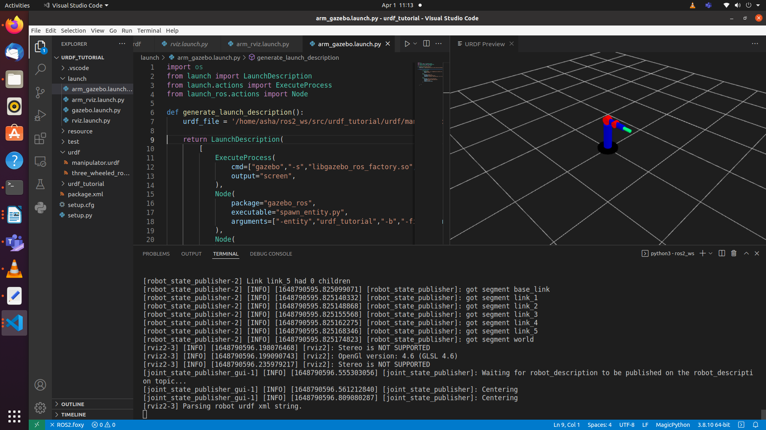

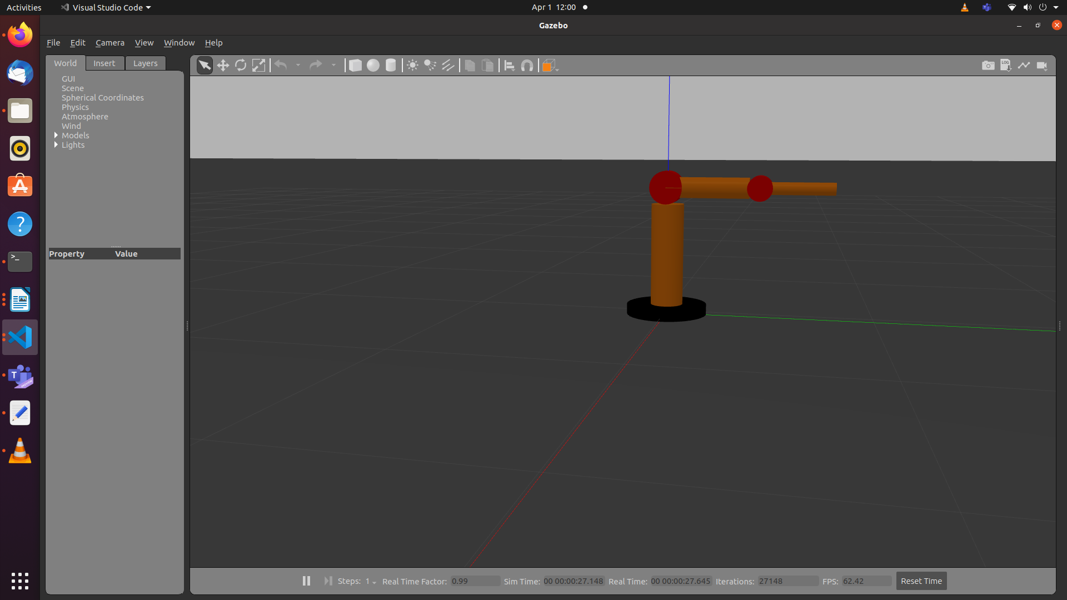

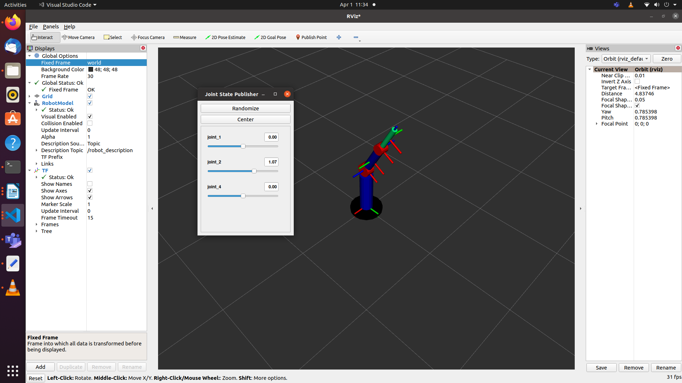

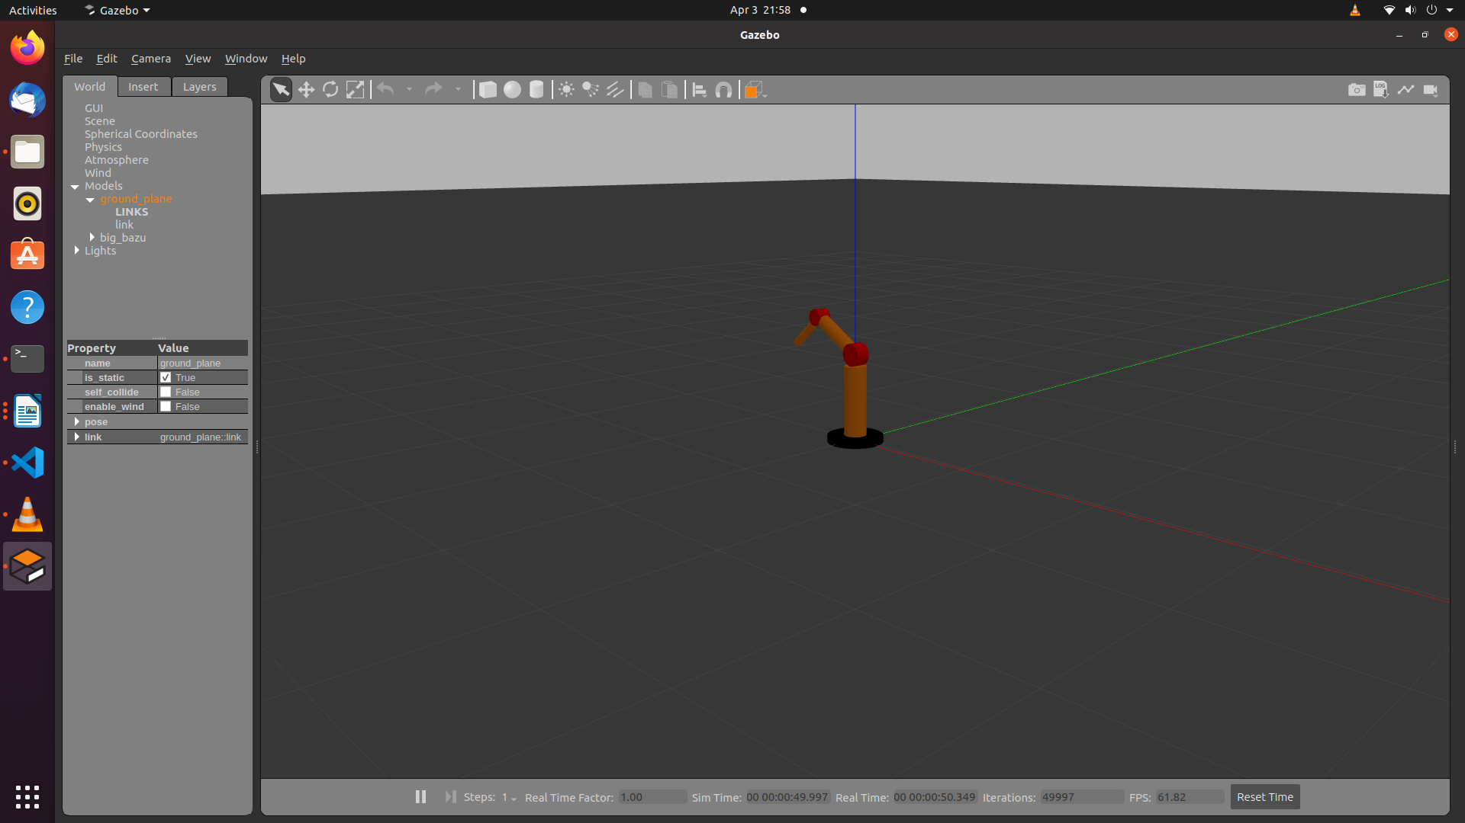

ROS2 parameters:

Parameters help to provide the values while running the code.

ros2 param list

Edit the controller.py

#!/usr/bin/env python3

#colcon build --packages-select urdf_tutorial
#ros2 run urdf_tutorial controller --ros-args -p end_location:=[3.5,1.5,-1.2]

import rclpy
from rclpy.node import Node
from builtin_interfaces.msg import Duration
from trajectory_msgs.msg import JointTrajectory, JointTrajectoryPoint

class TrajectoryPublisher(Node):

def __init__(self):
super().__init__('trajectory_node')
topic_ = "/joint_trajectory_controller/joint_trajectory"
self.joints = ['joint_1', 'joint_2', 'joint_4']
#self.goal_ =[1.5, 0.5, 1.2]
self.declare_parameter("joint_angles", [1.5, 0.5, 1.2])
self.goal_=self.get_parameter("joint_angles").value
self.publisher_ = self.create_publisher(JointTrajectory, topic_, 10)
self.timer_ = self.create_timer(1,self.timer_callback)

def timer_callback(self):
msg = JointTrajectory()
msg.joint_names = self.joints
point = JointTrajectoryPoint()
point.positions = self.goal_
point.time_from_start = Duration(sec=2)
msg.points.append(point)
self.publisher_.publish(msg)

def main(args=None):
rclpy.init(args=args)
node = TrajectoryPublisher()
rclpy.spin(node)
node.destroy_node()
rclpy.shutdown()

if __name__ == '__main__':
main()

Execute in Terminal #1
#colcon build --packages-select urdf_tutorial
Execute in Terminal #2
ros2 launch urdf_tutorial arm_control.launch.py
Execute in Terminal #3
#ros2 run urdf_tutorial controller --ros-args -p joint_angles:=[3.5,1.5,-1.2]

Exercise 1: Replicate the process for UR5e robot given its urdf file.

Exercise 2: Write a python code to move the manipulator to end location using inverse kinematics.

Viva Questions: Compute the inertia parameters for the each block used in the three_wheeled_robot and manipulator.

References

https://docs.ros.org/en/foxy/Tutorials/URDF/Using-URDF-with-Robot-State-Publisher.html
https://github.com/benbongalon/ros2-urdf-tutorial/tree/master/urdf_tutorial
https://github.com/cra-ros-pkg/robot_localization/tree/foxy-devel
https://github.com/ros/robot_state_publisher/tree/foxy
https://github.com/ros/joint_state_publisher/tree/foxy
http://gazebosim.org/tutorials?tut=ros_urdf

